|  |  |
| --- | --- |
| **Ticket ID** | T203800 |
| **Ticket description** | Connectus Madhe > Material Issue Madhe New Report Create Karne  Same As Attachment File |
| **Created by** | Tushar Shivaji Nikam |
| **Created on** | 05/03/2022 |
| **Priority** | High |
| **Version** | 3 |

**Version**

|  |  |  |  |  |
| --- | --- | --- | --- | --- |
| **Sr. No** | **Version no** | **Version Date** | **User name** | **User department** |
| 1 | 0 | 16.03.2022 | Tushar Shivaji Nikam | Inventory Silver HO |
| 2 | 1 | 23.03.2022 | Tushar Shivaji Nikam | Inventory Silver HO |
| 3 | 2 | 01.04.2022 | Tushar Shivaji Nikam | Inventory Silver HO |
| 4 | 3 | 06.04.2022 | Tushar Shivaji Nikam | Inventory Silver HO |

**Approvals**

|  |  |  |
| --- | --- | --- |
| **Field** | **Name of the User** | **Approved date by the user** |
| **Actual User Name** | Tushar Shivaji Nikam | 05.03.2022 |
| **Actual User Department** | Inventory Silver HO |  |
| **Organization Name** | C S Jewellers |  |
| **Sign-off** |  |  |
| **Assigned BA** | Mounika KrishnaVeni Annamneedi | 16.03.2022 |
| **Assigned Developer** |  |  |
| **Assigned Tester** |  |  |

**Estimation**

|  |  |  |  |  |
| --- | --- | --- | --- | --- |
| **Department name** | **Estimated Time (In hr)** | **Scheduled Date (Starting date )** | **Estimated date** | **Actual delivery date** |
| **BA** | 3 | 16.03.2022 | 17.03.2022 |  |
| **Development** |  |  |  |  |
| **Testing** |  |  |  |  |

**Business requirement**

In material issue main menu, material issue reports, the user requires a new report K Jama and RD report.

This report helps the user in knowing the rejected vendors and this report is helpful in reporting the higher management.

**Existing system**

In the existing system, there is no K Jama and RD report.

**Proposed system**

* Creation of new menu “Inventory reports”. And assigning the “Material issue reports” menu under the inventory reports.
* Creation of filter tab for suppliers
* Creation of the new report K Jama and RD report.
* Export of whole suppliers and single supplier chart both in .csv and pdf format.

**Step-1**

In Connect US -> Material Issue Main Menu -> Add “Inventory reports” and under it, add “Material issue reports”

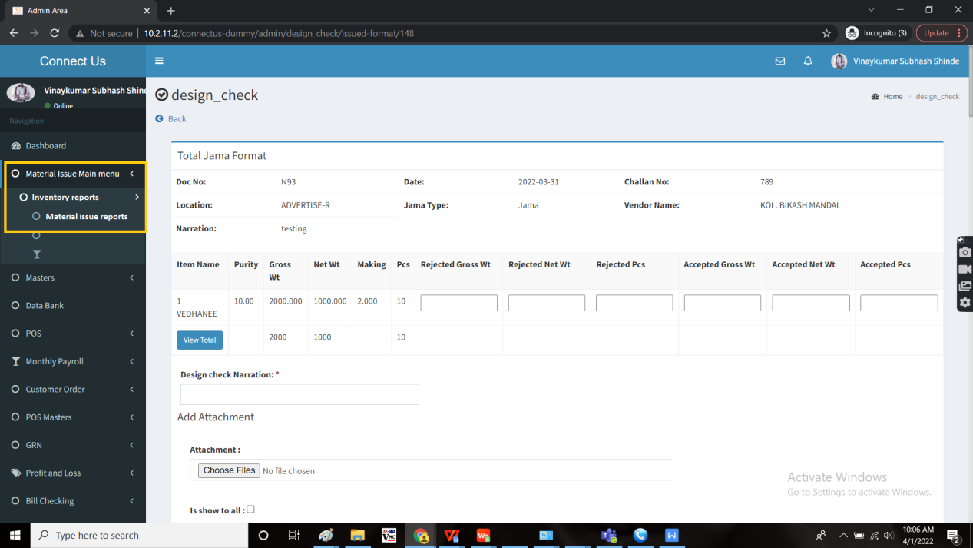

Add new report “K Jama” and “RD Reports” and a filter for suppliers.

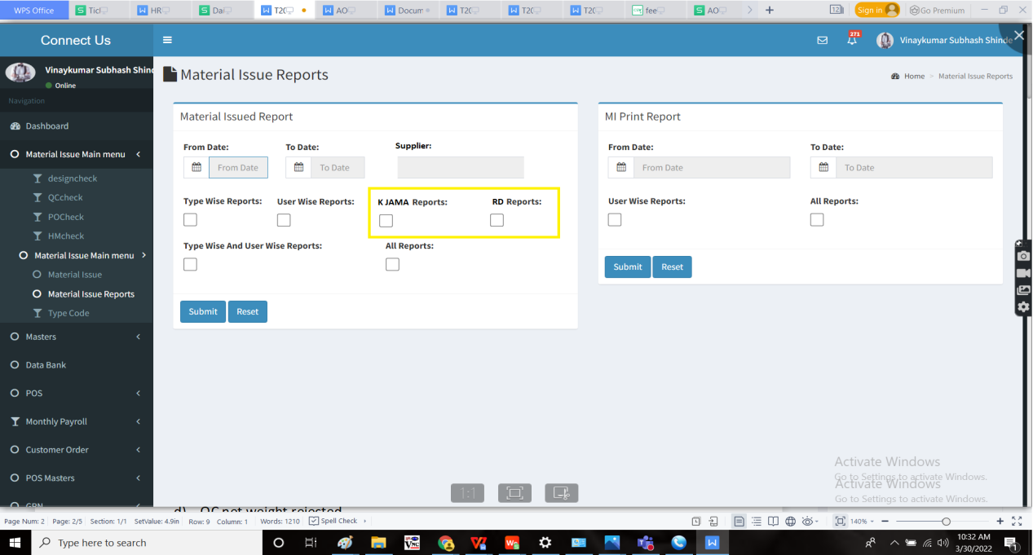

The report consists of the following fields

1. K Jama Report
   1. Karagir name
   2. Jama net weight
   3. Design net weight rejected
   4. QC net weight rejected
   5. PO net weight rejected
   6. HM net weight rejected
   7. Net weight accepted
   8. Design net weight rejected % = [(Design net weight rejected/ Jama net weight) *100]
   9. QC net weight rejected % = [(QC net weight rejected/ Jama net weight) *100]
   10. PO net weight rejected % = [(PO net weight rejected/ Jama net weight) *100]
   11. HM net weight rejected % = [(HM net weight rejected/ Jama net weight) *100]
   12. Net weight accepted % = [(Net weight accepted/ Jama net weight) *100]
   13. Total net weight rejected % = [(Total net weight rejected/ Jama net weight) *100]
   14. Chart
2. RD
   1. Karagir name
   2. Jama net weight
   3. Design net weight rejected
   4. QC net weight rejected
   5. PO net weight rejected
   6. HM net weight rejected
   7. Net weight accepted
   8. Design net weight rejected % = [(Design net weight rejected/ Jama net weight) *100]
   9. QC net weight rejected % = [(QC net weight rejected/ Jama net weight) *100]
   10. PO net weight rejected % = [(PO net weight rejected/ Jama net weight) *100]
   11. HM net weight rejected % = [(HM net weight rejected/ Jama net weight) *100]
   12. Net weight accepted % = [(Net weight accepted/ Jama net weight) *100]
   13. Total net weight rejected % = [(Total net weight rejected/ Jama net weight) *100]
   14. Chart

The data is fetched from the material issue main menu - design check, QC check, PO check and HM check.

The filter of suppliers should have the option of selecting all the suppliers and single or multiple suppliers. The data of the suppliers is fetched from vendor master from bill checking module.

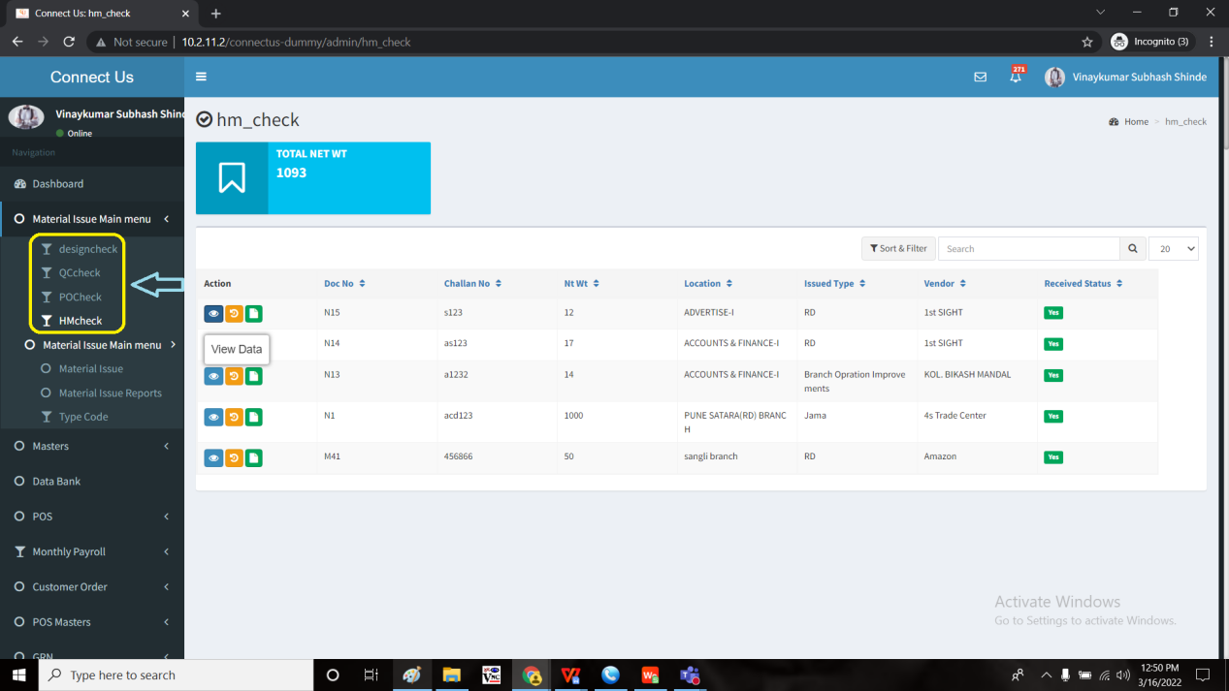

When the user fills the data and clicks on submit, the following data is displayed. The report consists of the export button where it can be exported both in .csv and pdf format.

Calculation sample:

For both K Jama and RD

Ashok (Karagir) having 4 documents named N1, N2, N3, N4.

Therefore, the report consists of the addition of 4 documents.

|  |  |  |  |  |  |  |
| --- | --- | --- | --- | --- | --- | --- |
| Karagir name - AShok | Jama net weight | Design net wt rejected | QC net wt rejected | PO net wt rejected | HM net wt rejected | Net wt accepted |
| N1 | 10 | 1 | 0 | 0 | 0 | 9 |
| N2 | 20 | 0 | 0 | 0 | 0 | 20 |
| N3 | 40 | 4 | 0 | 0 | 0 | 36 |
| N4 | 30 | 5 | 0 | 0 | 0 | 25 |

There Karagir - Ashok = Jama net weight = N1+N2+N3+N4 = 10+20+40+30 = 100

|  |  |  |  |  |  |  |  |  |  |  |  |  |
| --- | --- | --- | --- | --- | --- | --- | --- | --- | --- | --- | --- | --- |
| Karagir name | Jama net weight | Design net wt rejected | QC net wt rejected | PO net wt rejected | HM net wt rejected | Net wt accepted | Design net wt rejected % | QC net wt rejected % | PO net wt rejected % | HM net wt rejected % | Net wt accepted % | Total weight rejected % |
| Ashok | 100 | 10 | 0 | 0 | 0 | 90 | 10% | 0% | 0% | 0% | 90% | 10% |
| Argentinum | 200 | 20 | 20 | 0 | 0 | 160 | 10% | 10% | 0% | 0% | 80% | 20% |

OUTPUT: When the K Jama is exported in .csv format

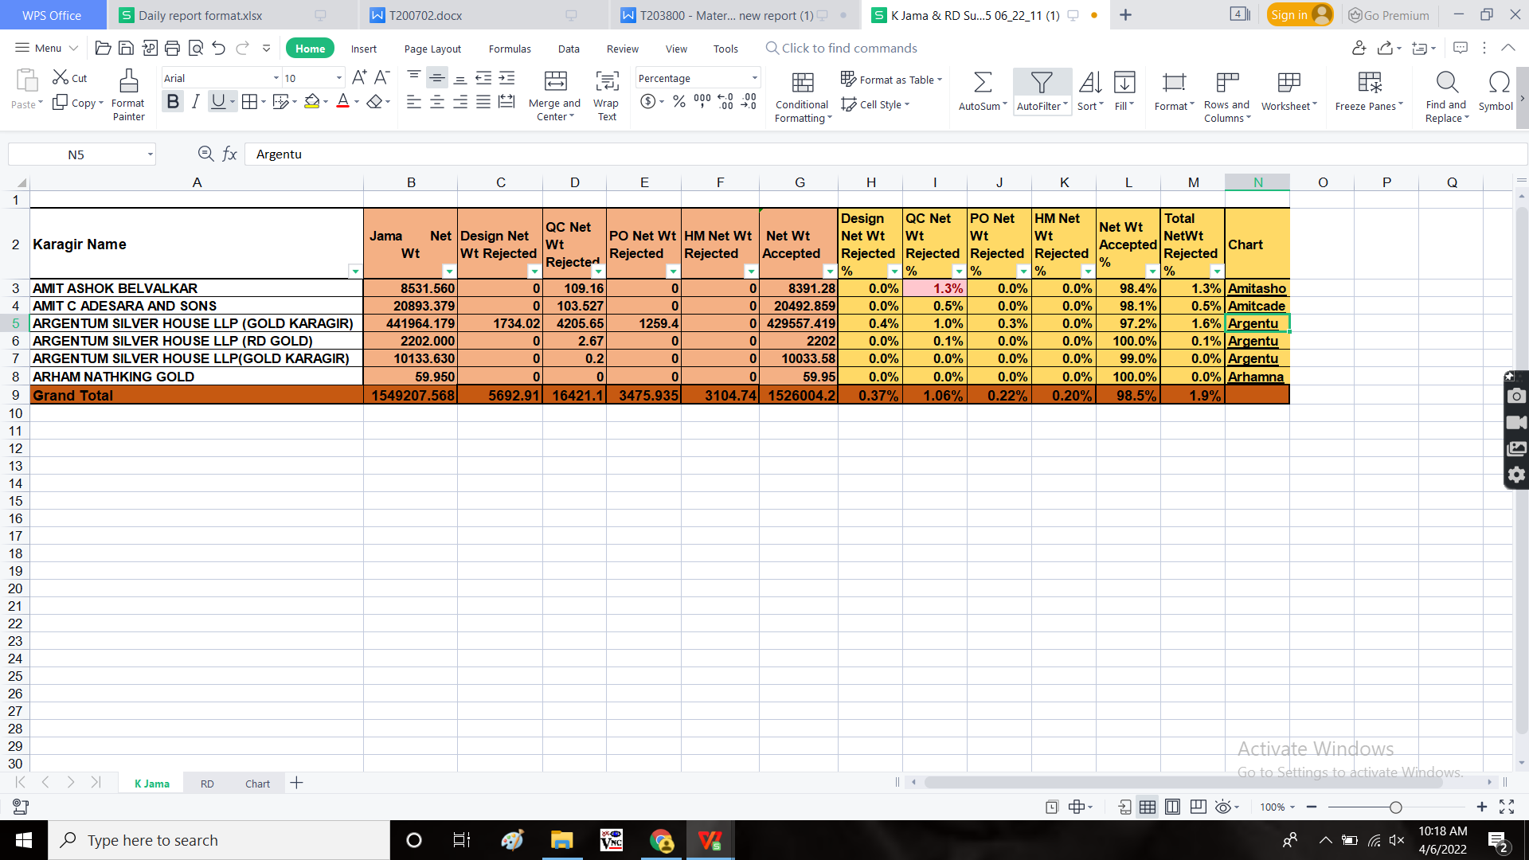

OUTPUT: When the RD is exported in .csv format

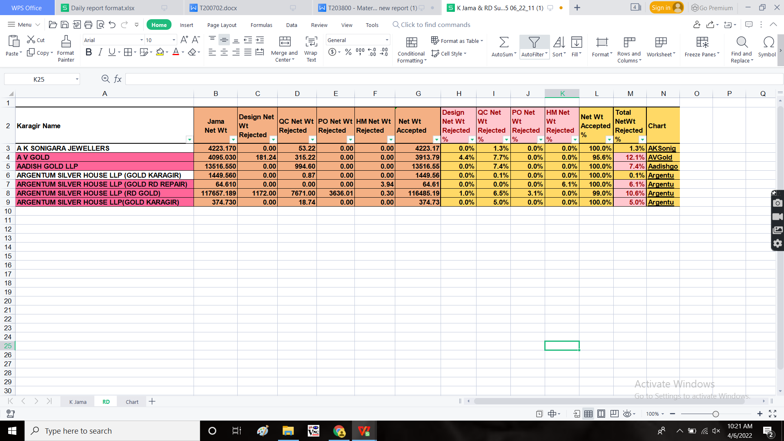

When the user clicks on the link in the chart, it re-directs to the report of a single supplier, the user selected. The report consists of the single Karagir name and the report in the pie-chart format.

There should be an export button when user selects the specific karagir (the details of the karagir and the chart to be exported). The data to be exported both in .csv and pdf format.

OUTPUT :

When single supplier is exported in .csv

|  |  |  |  |  |  |  |  |  |  |  |  |  |
| --- | --- | --- | --- | --- | --- | --- | --- | --- | --- | --- | --- | --- |
| **Karagir Name** | **Jama Net Wt** | **Design Net Wt Rejected** | **QC Net Wt Rejected** | **PO Net Wt Rejected** | **HM Net Wt Rejected** | **Net Wt Accepted** | **Design Net Wt Rejected %** | **QC Net Wt Rejected %** | **PO Net Wt Rejected %** | **HM Net Wt Rejected %** | **Net Wt Accepted %** | **Total NetWt Rejected %** |
| **ARGENTUM SILVER HOUSE LLP (RD GOLD)** | **117657.189** | **1172.00** | **7671.00** | **3636.01** | **0.30** | **116485.19** | **1.0%** | **6.5%** | **3.1%** | **0.0%** | **90.0%** | **10.6%** |

Note:

The report consists of karagir values of the particular karagir. This report is the merging data of the specific karagir.

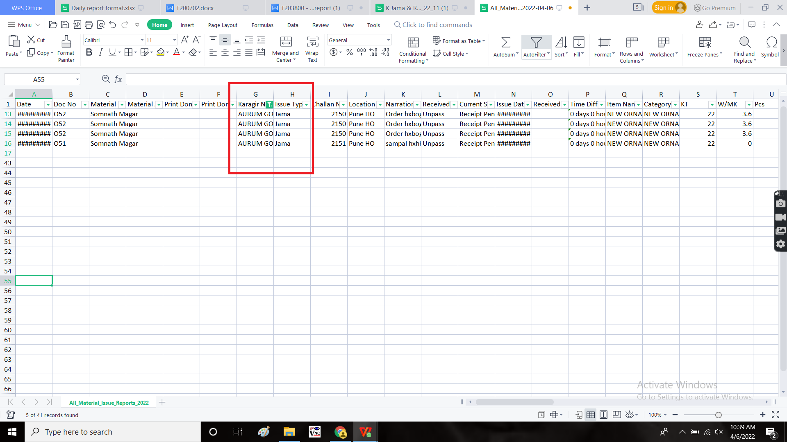

**References of the users**

|  |  |  |  |
| --- | --- | --- | --- |
| **User** | **Name** | **Mail** | **Contact number** |
| **Actual user** | Tushar Shivaji Nikam | designgd@csjewellers.com |  |
| **Assigned business analyst** | Mounika KrishnaVeni Annamneedi | Mounika.annamneedi@techneai.com | 8669917920 |
| **Assigned developer** |  |  |  |
| **Assigned tester** | Monika Kolpe | Monika.kolpe@techneai.com |  |