|  |  |
| --- | --- |
| **Ticket ID** | T205308 |
| **Ticket description** | ConnectUS Madhe > Material Issue Main Menu Pramane Silver Sathi Provision Karne  1) CSPL Order Place  2) Shripal Gems & Jewellery Order Recive  2) Shripal Gems & Jewellery Order Details Update And Forwerd To CSPL  3) Receive Order CSPL  4) Forward To Design Check  5) Forward To QC Check  6) Forward To PO Check  7) Forward To HM  Last Complete To Silver Jama DPT  Ya Type Madhe Karne |
| **Created by** | Tushar Shivaji Nikam |
| **Created on** | 12/03/2022 |
| **Priority** | Very High |
| **Version** | 0 |

**Version**

|  |  |  |  |  |
| --- | --- | --- | --- | --- |
| **Sr. No** | **Version no** | **Version Date** | **User name** | **User department** |
| 1 | 0 | 27.04.2022 | Tushar Shivaji Nikam | Inventory Silver HO |

**Approvals**

|  |  |  |
| --- | --- | --- |
| **Field** | **Name of the User** | **Approved date by the user** |
| **Actual User Name** | Tushar Shivaji Nikam | 12.03.2022 |
| **Actual User Department** | Inventory Silver HO |  |
| **Organization Name** | C S Jewellers |  |
| **Sign-off** |  |  |
| **Assigned BA** | Mounika KrishnaVeni Annamneedi | 27.04.2022 |
| **Assigned Developer** |  |  |
| **Assigned Tester** |  |  |

**Estimation**

|  |  |  |  |  |
| --- | --- | --- | --- | --- |
| **Department name** | **Estimated Time (In hr)** | **Scheduled Date (Starting date )** | **Estimated date** | **Actual delivery date** |
| **BA** | 3 | 27.04.2022 | 27.04.2022 |  |
| **Development** |  |  |  |  |
| **Testing** |  |  |  |  |

**Business requirement**

In material issue main menu, the user requires new menu for the material issue silver. This menu helps in storing the information, processing in connect us and generating the reports in the connect us.

**Existing system**

In the existing system, there is no system for the material issue silver.

**Proposed system**

* Creation of new master in Material issue menu “vendor registration”.
* Creation of special privilege for the vendor.
* Creation of new menu “material issue silver” under Material issue main menu.
* Under material issue silver, approved HM check reports will be shown.

For user view

* + - CS order silver
    - Design check
    - QC check
    - PO check
    - HM check
    - Material issue silver
    - Material issue silver reports

For vendor view

* + - CS order silver

**Process:**

Step 1:

User view menu

In material issue main menu, addition of 3 new menu’s

1. CS order silver
2. Material issue silver
3. Material issue silver reports
4. Vendor registration

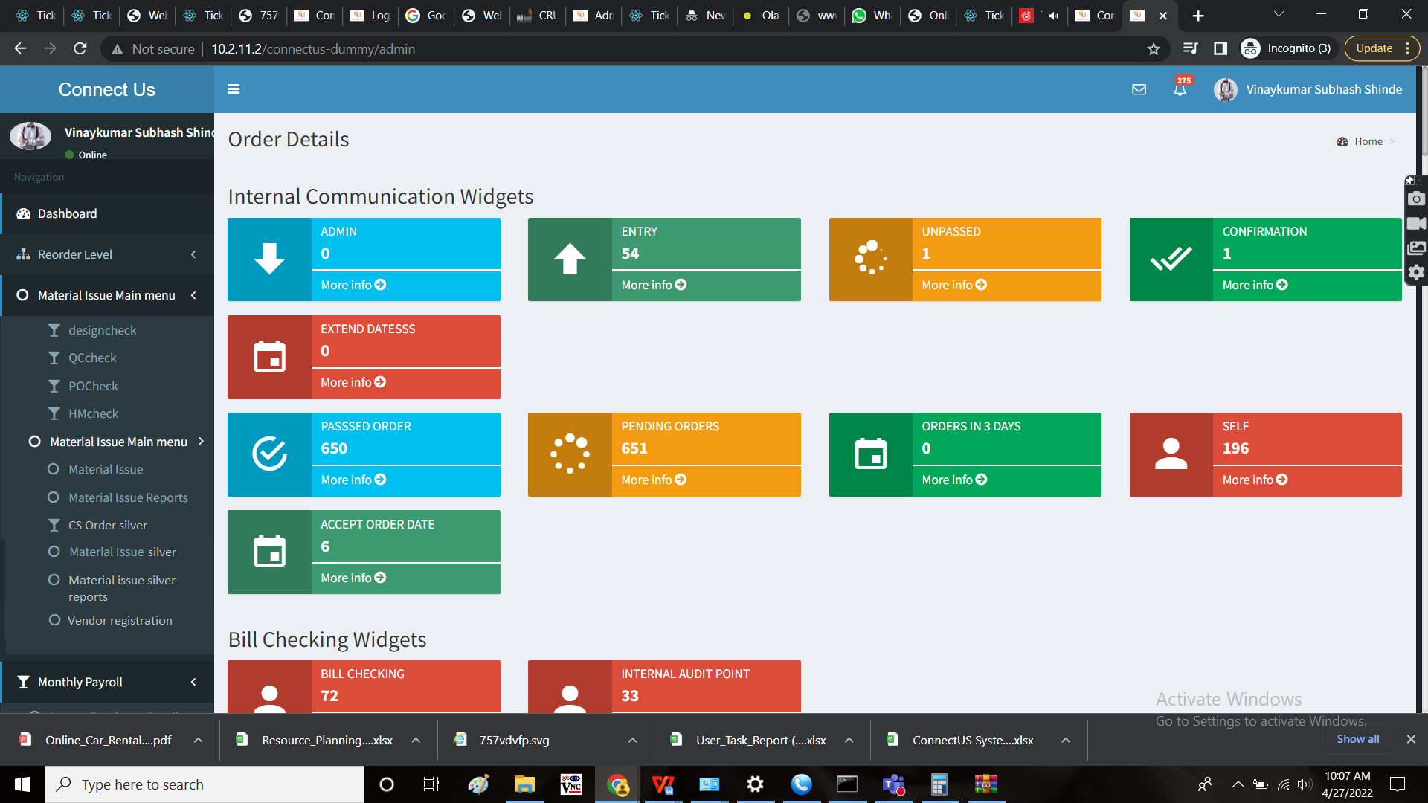

Step 2:

Vendor view menu

In material issue main menu, only CS order silver is shown.

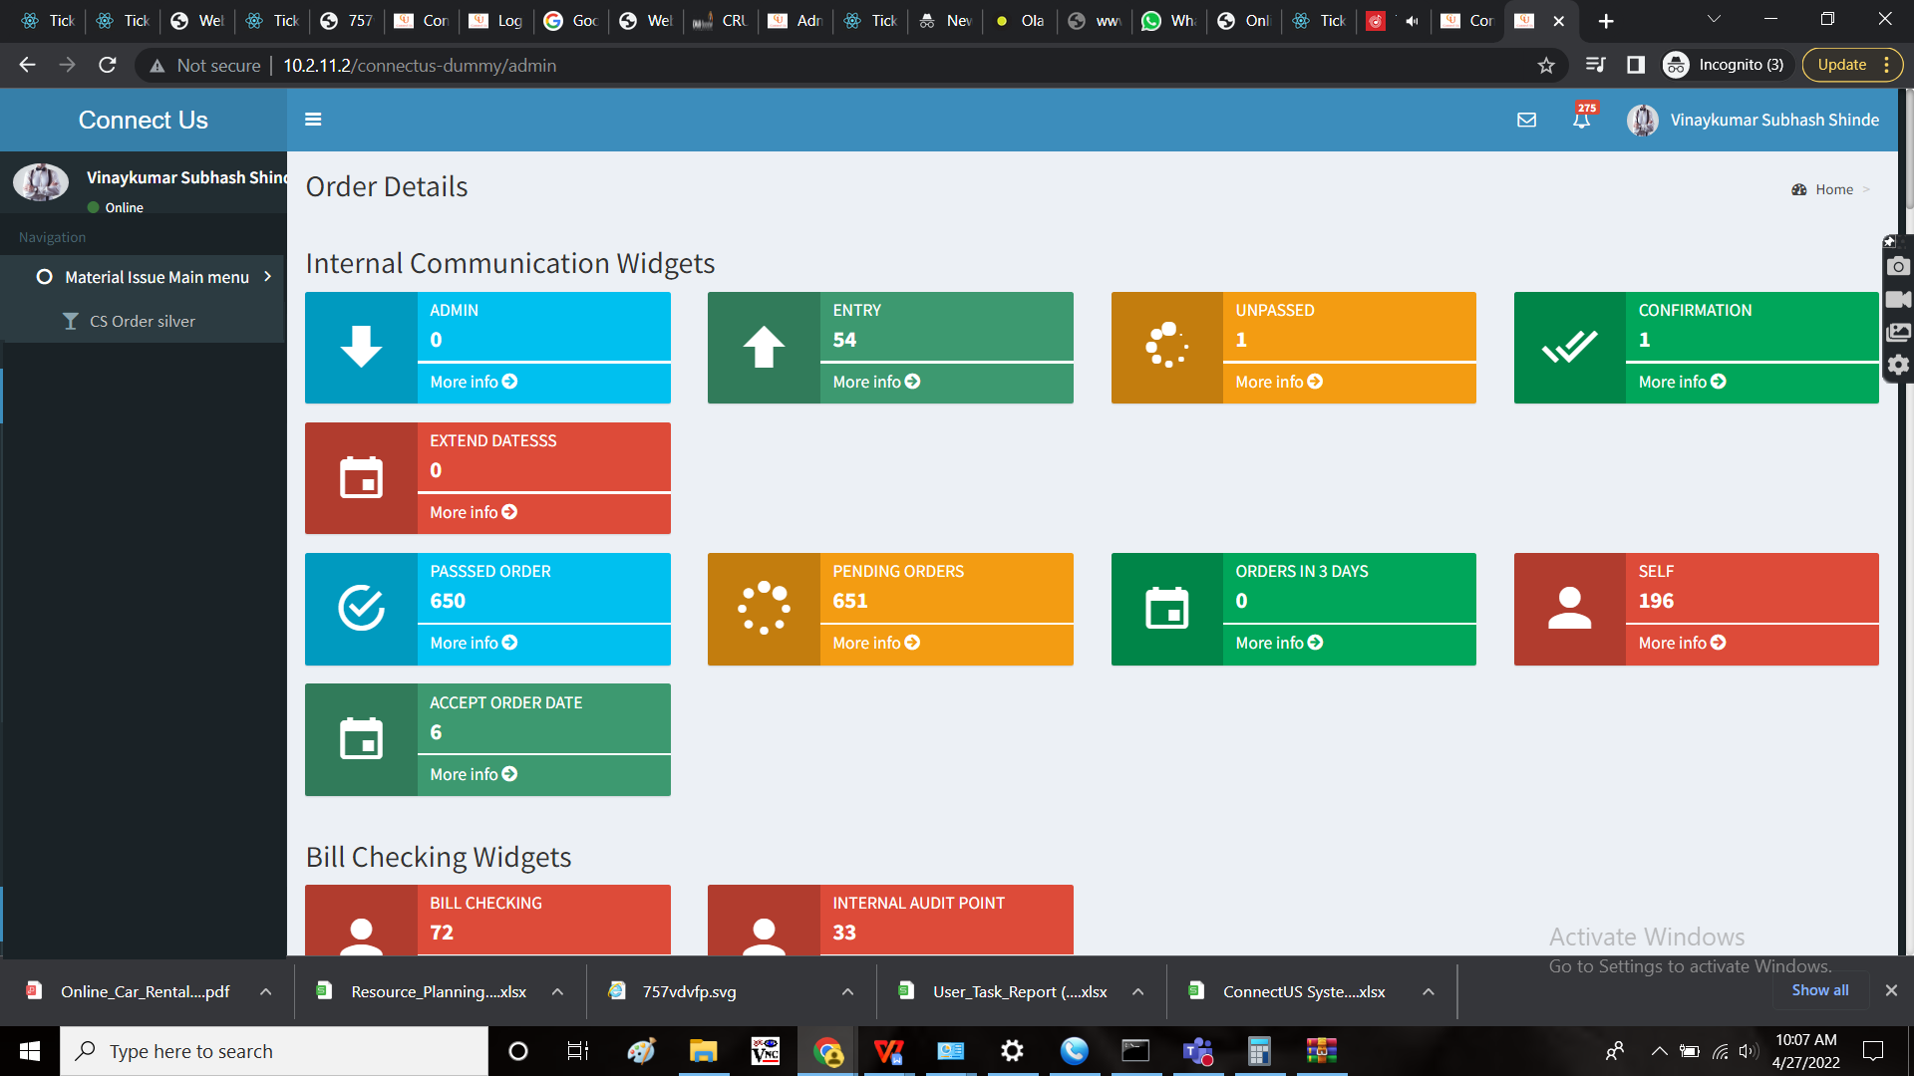

Step 3:

Creation of the new master “Vendor Registration Master”.

In this master, the user add the vendor details and creates the login id and password to the vendor. The vendor can login in connect us with the email and password given in this master by the user. This is communicated by the user to the vendor.

Initially, there is an add button in the menu to add the data.

The page consists of the details of the existing vendor in the list view.

The following are the fields in the master

* Action button to view, edit and delete the data.
* ID
* Company
* Vendor name
* Contact name
* Vendor type
* Email
* Mobile No
* Address

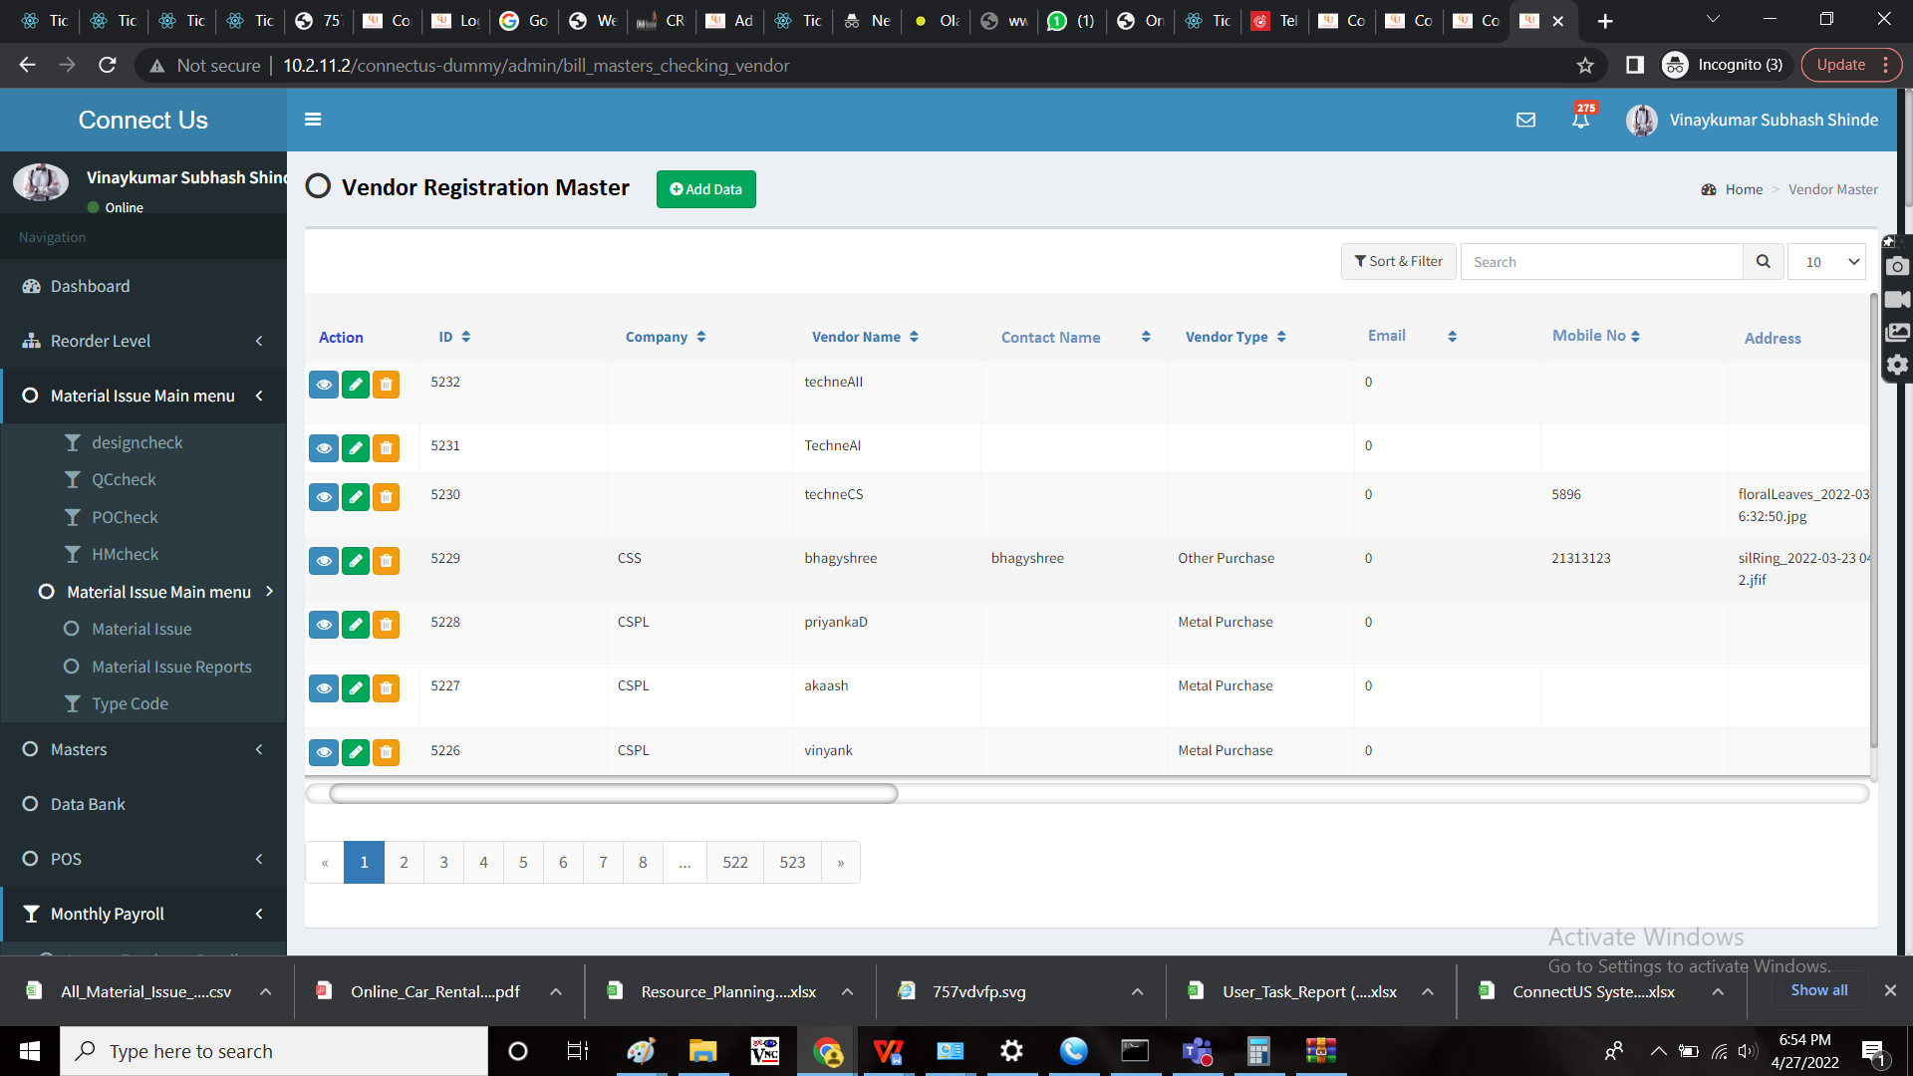

Add data:

The following are the details in the add menu

* ID
* Company
* Vendor name
* Contact name
* Vendor type
* Email
* Mobile No
* Address
* Password

|  |  |  |  |
| --- | --- | --- | --- |
| Field | Type | Mandatory/ optional | Description |
| ID | Auto-generated | - | The unique ID for each vendor |
| Company | Drop-down | Optional | The company selected from the drop-down menu |
| Vendor name | Text | Mandatory | The vendor name is entered |
| Contact name | Text | Mandatory | The contact name of the vendor is entered |
| Vendor type | Drop-down | Mandatory | The vendor type is selected from the drop down |
| Email | Text | Mandatory | The email Id of the user is entered. The email id is used for the login purpose. |
| Mobile No | Int | Mandatory | The mobile no of the user is entered |
| Address | Text | Optional | The user address is entered |
| Password | Text | Mandatory | The password is entered. This password is as the password for the login |

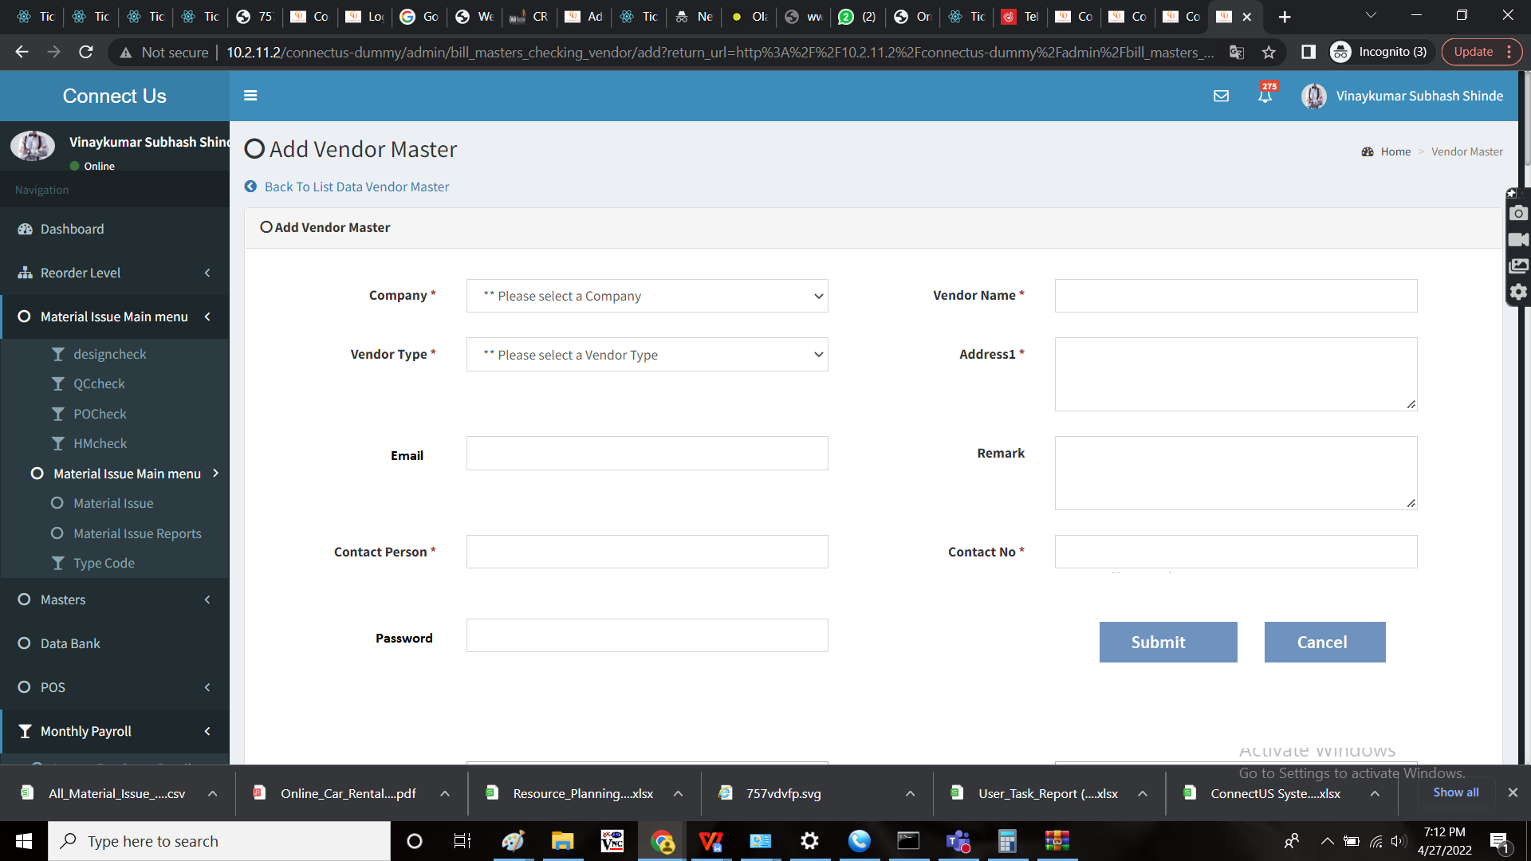

Step 4:

Assigning privilege to the user. Privilege is given by the user. In privilege role, by adding privilege and assigning that privilege to the vendors.

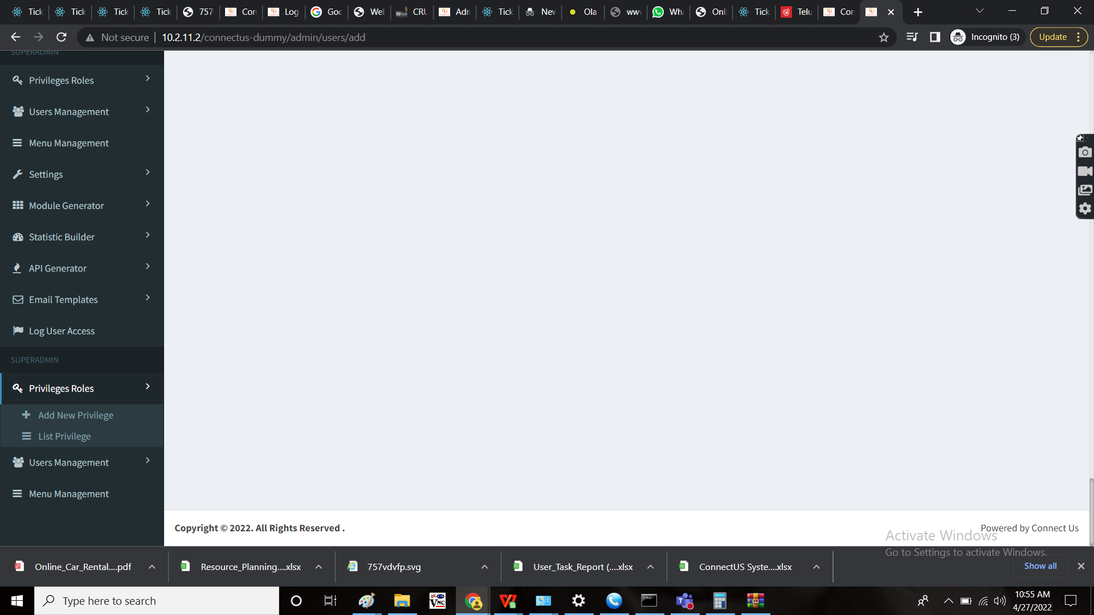

Step 5:

The vendor to be added in vendor master which is in bill checking -> bill checking masters -> vendor master. This process is done by the user.

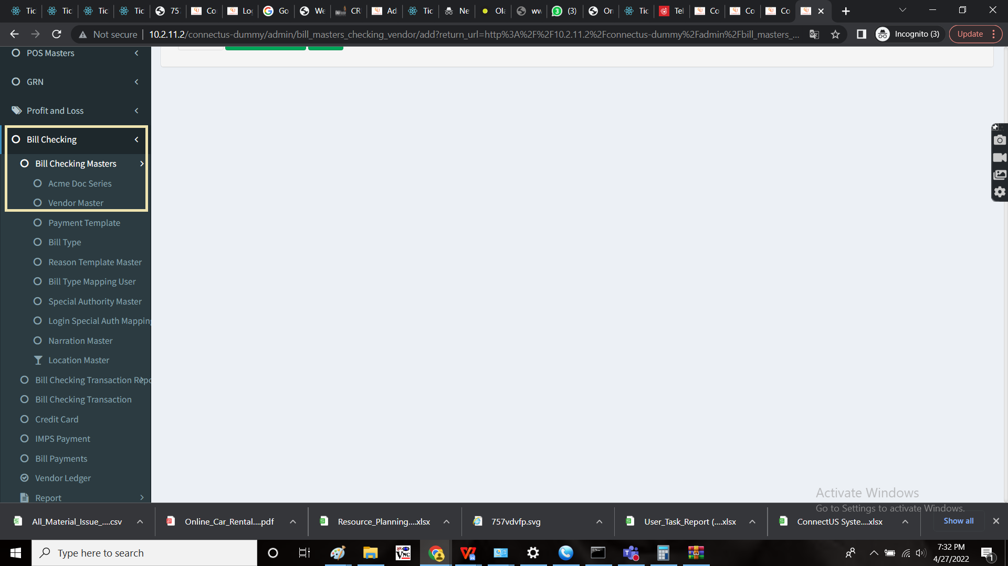

Step 6:

User side - CS order silver.

The user side, CS order silver contains the following buttons.

* Add data button
* Export button
* Import button
* Submit button
* Cancel button

Step 6:

The vendor side, CS order silver.

The vendor have the option of editing the sent document by clicking edit button in the action button.

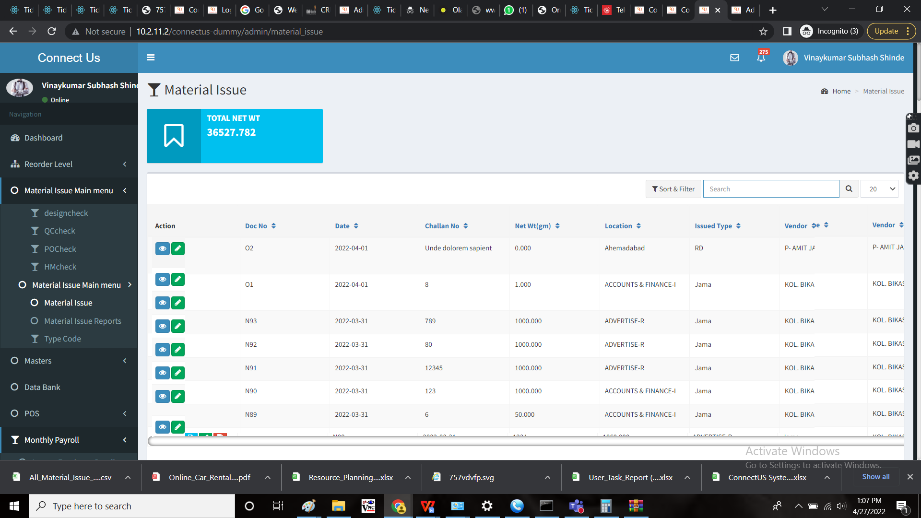

The vendor views the new field “Inward pcs” and have the option to edit the no. Of pieces. The inward pcs is the pieces count available with the vendor.

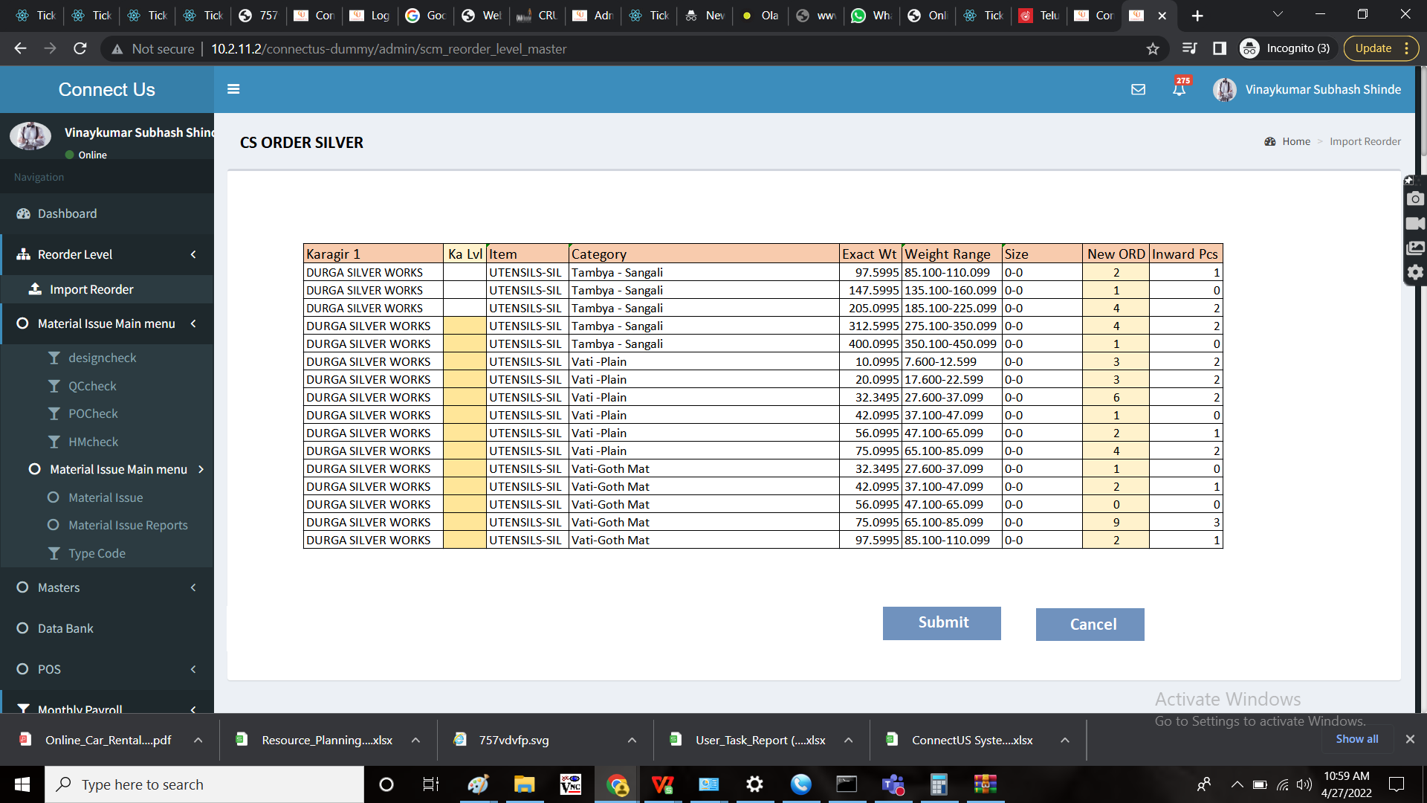

When the vendor submits the data, it directs to the material issue silver categorized into karagir wise, item wise and category wise.

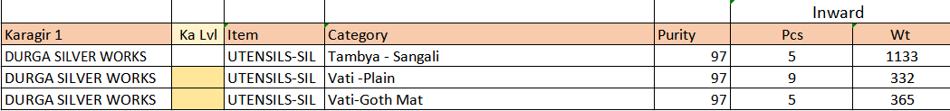

Step 7:

Material issue silver

In the material issue silver, the user have an extra button in action column to accept the order from the vendor. When the user accepts the data, then it directs to design check.

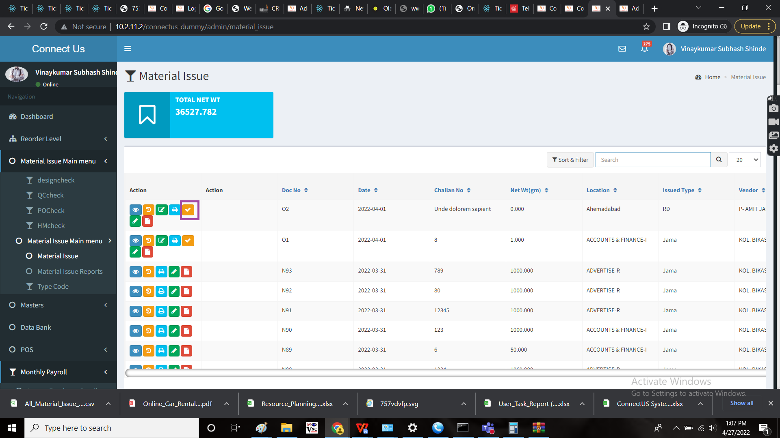

Material issue silver also consists of the data which approved from the HM check as the record.

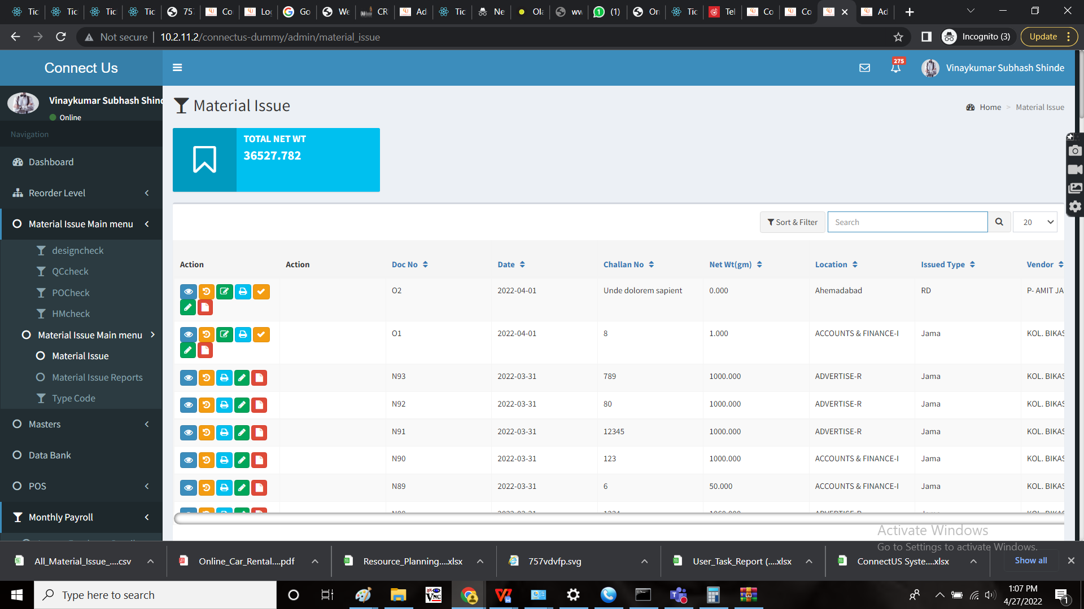

Step 8:

Design check to Material issue silver.

The process is same as the existing one. From design check to QC check, from QC check to PO check, from PO check to HM check. Once accepted in HM check, it directs to material issue silver.

Design check

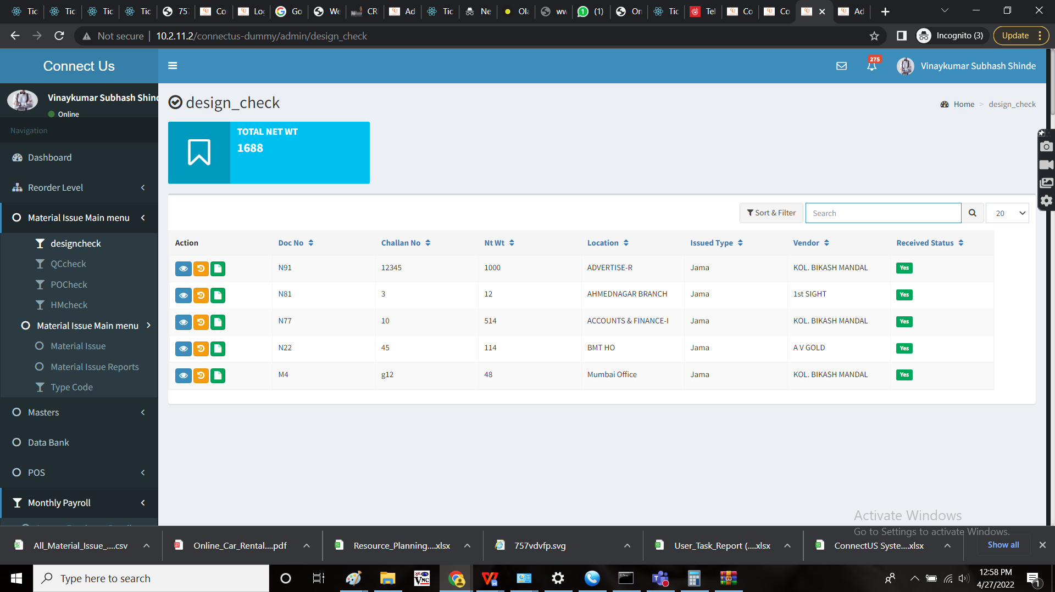

Design check issued format

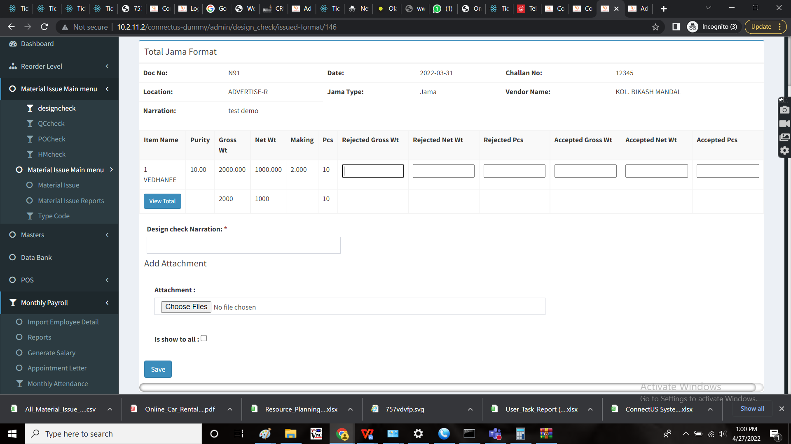

QC check

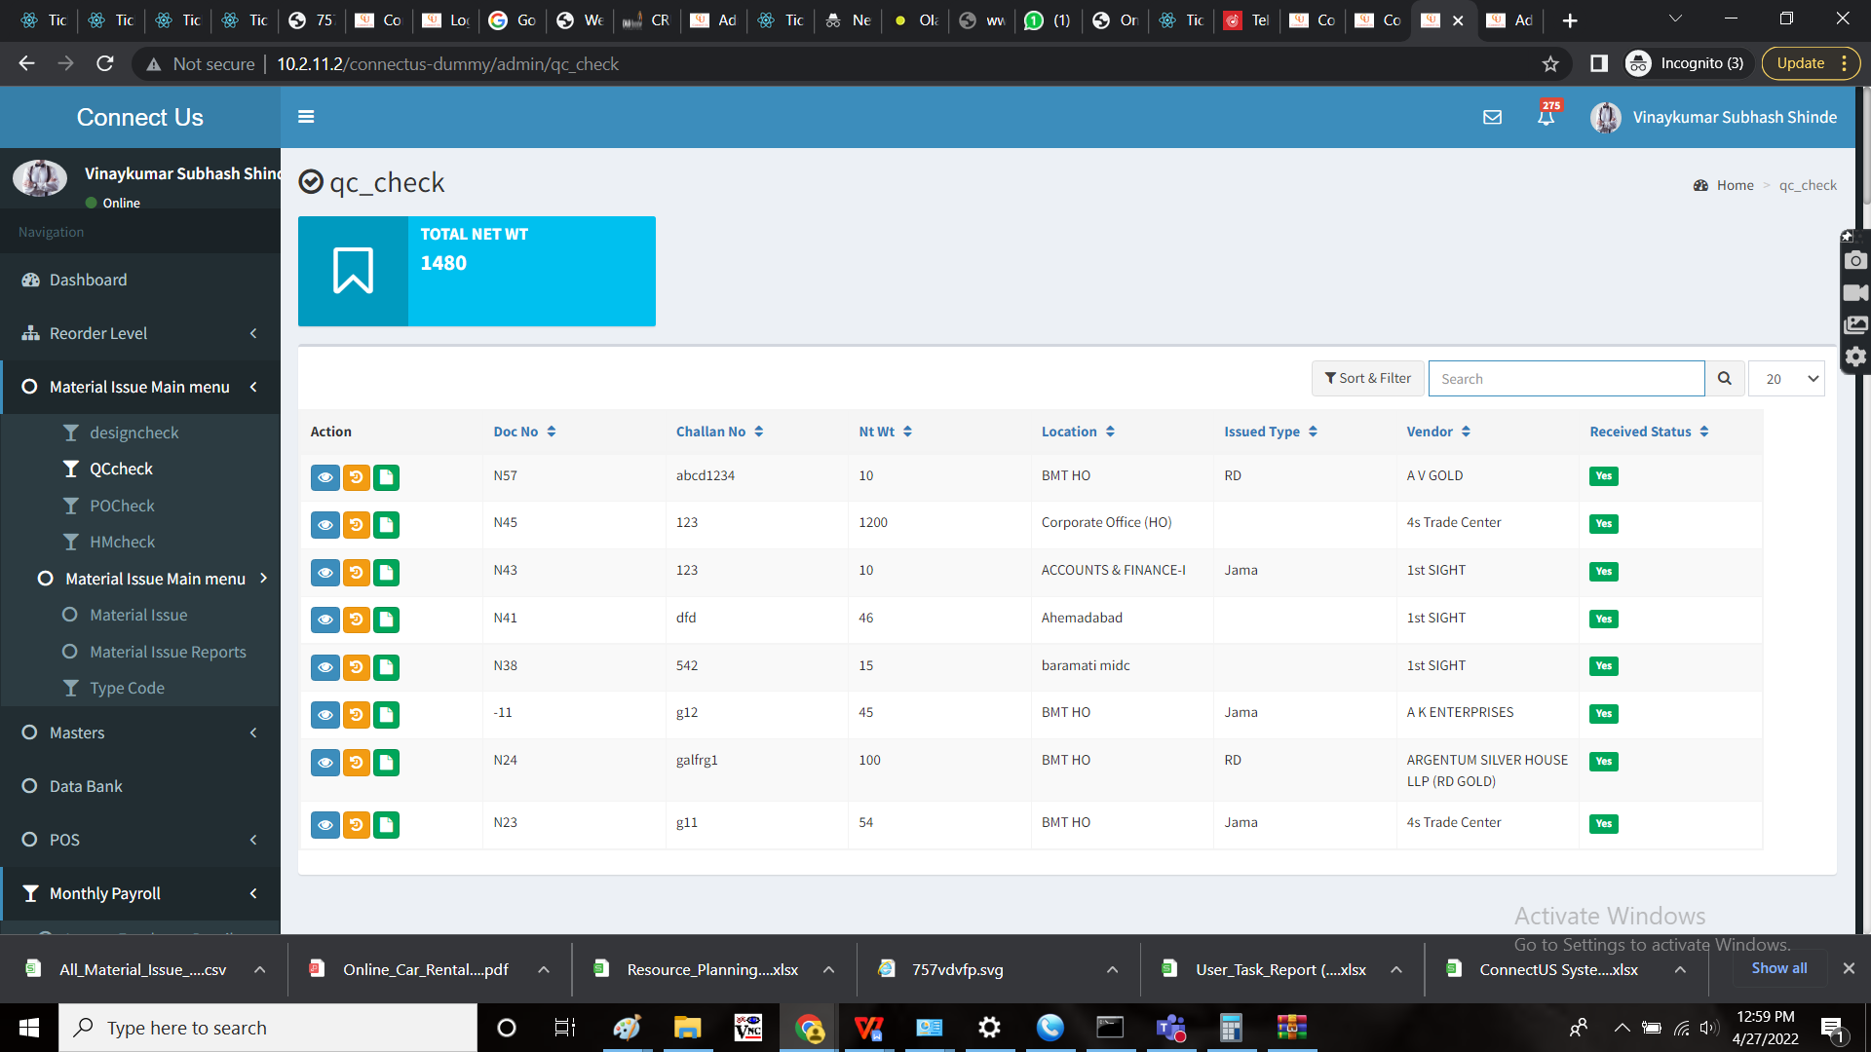

QC Check issued format

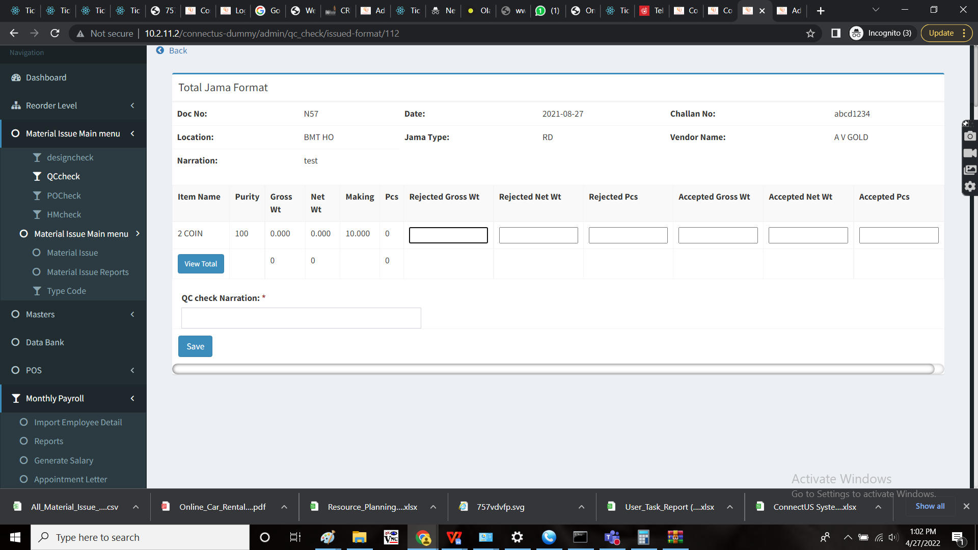

PO check

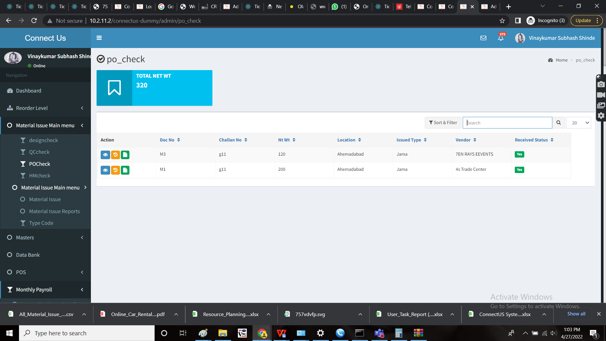

PO check issued format

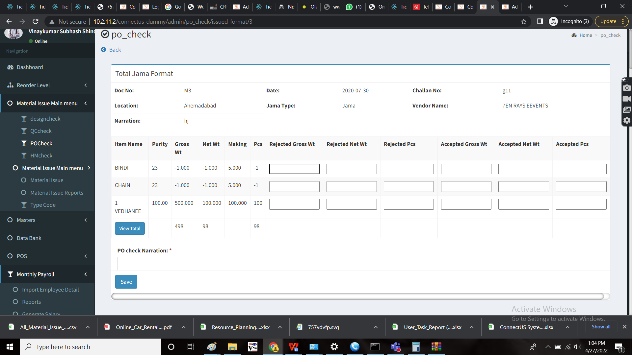

HM check

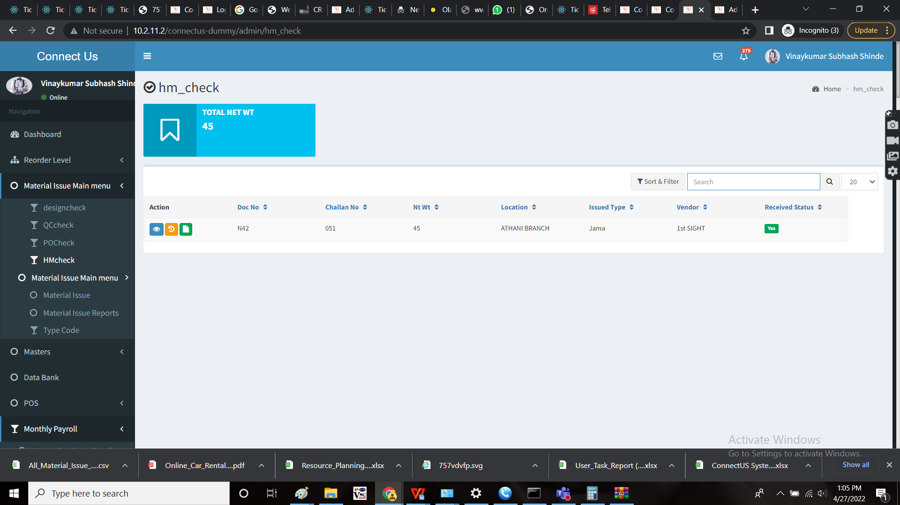

HM check issued format

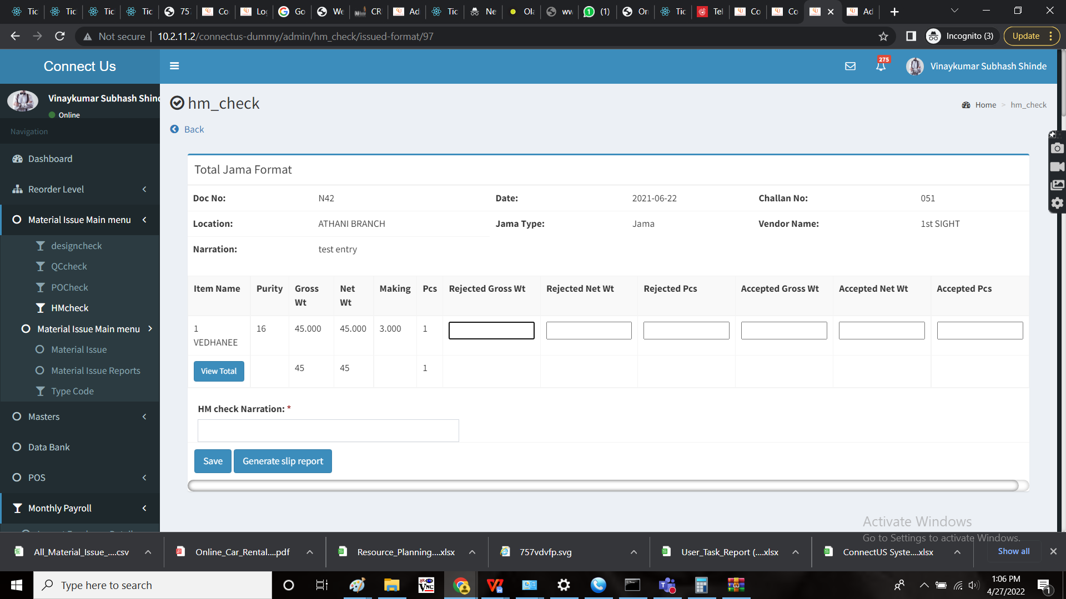

Material issue silver



Step 9:

Material issue silver reports

The reports were generated. The filters are based on from date and to date.

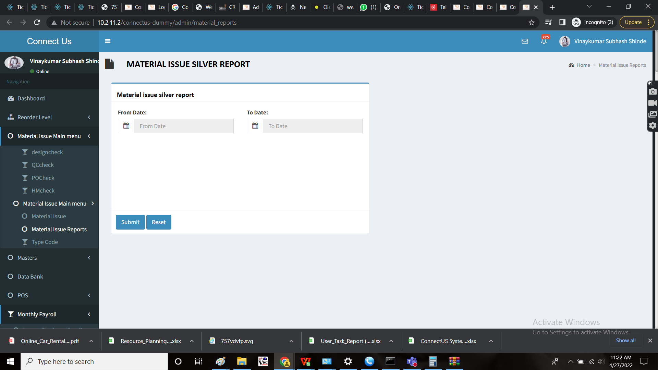

When the user enters the from date and to date and submits, the following report is generated.

There should be an export button to export the data. The data is exported in .csv format.

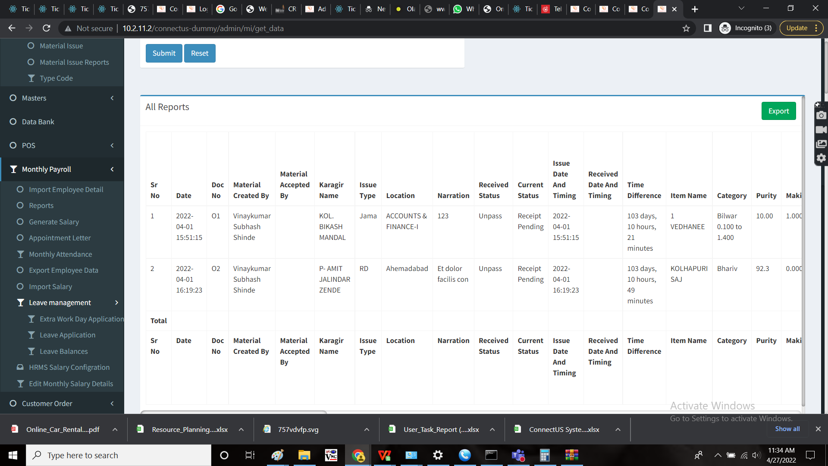

The following were the fields in the report.

* Sr no
* Date
* Document no.
* Material created by
* Material accepted by
* Karagir name
* Issue type
* Location
* Narration
* Received status
* Current status
* Issue date and timing
* Received date and timing
* Time difference
* Item name
* Category
* Purity
* Pcs
* Gross wt
* Net wt
* Design gross wt rejected
* Design net wt rejected
* Design pcs rejected
* Design gross wt accepted
* Design net wt accepted
* Design pcs accepted
* Design narration
* QC gross wt rejected
* QC net wt rejected
* QC pcs rejected
* QC gross wt accepted
* QC net wt accepted
* QC pcs accepted
* QC narration
* PO gross wt rejected
* PO net wt rejected
* PO pcs rejected
* PO gross wt accepted
* PO net wt accepted
* PO pcs accepted
* PO narration
* HM gross wt rejected
* HM net wt rejected
* HM pcs rejected
* HM gross wt accepted
* HM net wt accepted
* HM pcs accepted
* HM narration
* Add to receive status
* Received status to design check update
* Design check update to QC check update
* QC check update to PO check update
* PO check update to HM check update
* Time difference (Start to end MI process)

Excel sheet when exported:

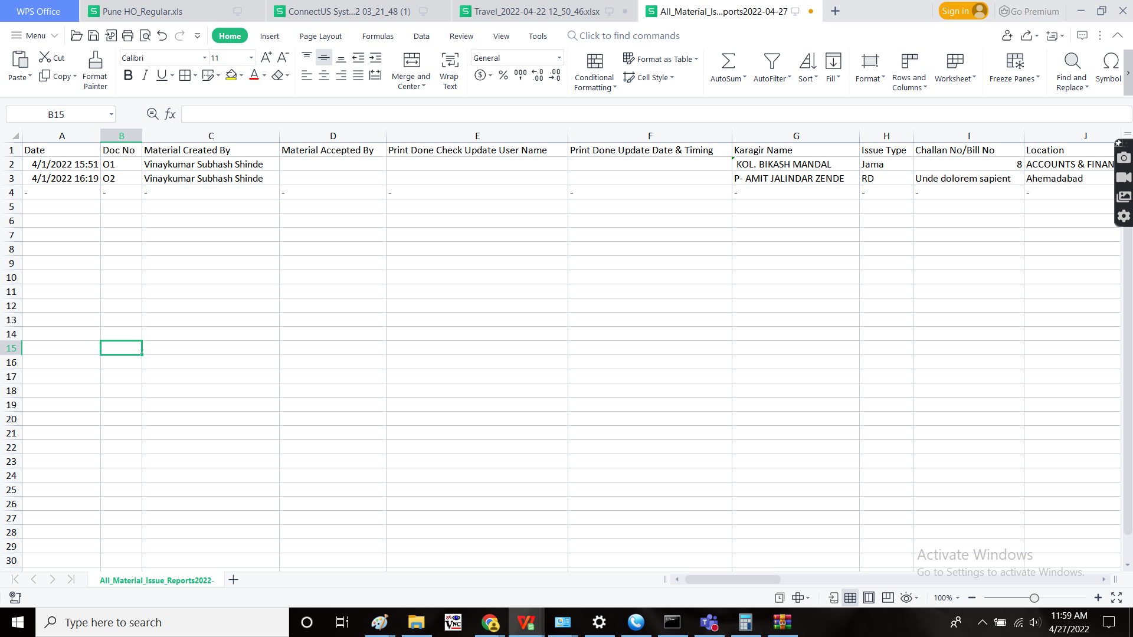

**References of the users**

|  |  |  |  |
| --- | --- | --- | --- |
| **User** | **Name** | **Mail** | **Contact number** |
| **Actual user** | Tushar Shivaji Nikam | designgd@csjewellers.com |  |
| **Assigned business analyst** | Mounika KrishnaVeni Annamneedi | Mounika.annamneedi@techneai.com | 8669917920 |
| **Assigned developer** |  |  |  |
| **Assigned tester** | Monika Kolpe | Monika.kolpe@techneai.com |  |